Day 1: Almaty
Your guide will meet you at the airport and transfer you to the hotel. Today you will visit the Green Bazaar, where it is impossible to refrain from shopping. Then the tour will continue in one of the oldest Almaty parks - Panfilov Park, where one of the most beautiful wooden buildings in the world - Zenkov Cathedral is located. After exploration of sport, cultural and business areas of the city, you will get to the Medeo Gorge. Next destination is the Kok-Tobe hill where the tallest TV tower in the world is located (if to count from the sea level) and where you will get by the picturesque winding mountain road. In Kok-Tobe Park, you can stroll along the winding paths of the park, admire the magnificent panorama of the city from the special observation deck and visit the shop of national souvenirs. The tour ends with the short ride from the top of the hill to the center of the city by the famous Almaty cableway. Transfer to the hotel.

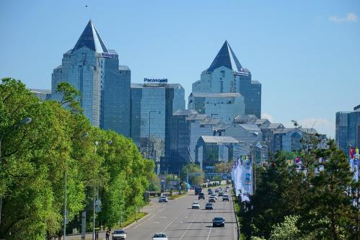
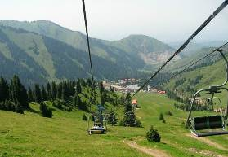

Day 2: Almaty – Charyn Canyon – Almaty
Today you will have a day trip to Charyn Cabyons. It is one of the unique natural monuments of Kazakhstan. The canyon is about 12 million years old and surprises with its vertical cliffs, reminding the ancient castles, created by wind, sun and rain. It will take about 3 hours to reach the canyon. Meanwhile, you will hear a lot of interesting about the history and nature of the region, about Kazakh people, their life and traditions as well as have a lunch in a local cafe. In addition, as soon as you see Charyn Canyon you will forget about this long way at once - so much you will be impressed with the beauty and splendor of the canyon. You can admire the grand panorama and then have a walk through the maze of the Castles Valley with its inaccessible walls overhanging you. In the evening is transfer to the hotel.

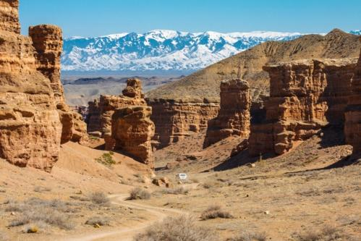
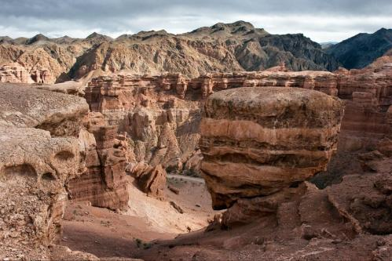

Day 3: Almaty – Issyk Lake – Almaty
The tour route to one of the most beautiful gorges of Trans-Ili Ala-Tau - Issyk Gorge lies along the Kuldja tract, where hundreds of years ago the trade caravans travelled. On the way, you will visit the State Historical and Cultural Museum-Reserve “ISSYK”, where you will see the expositions dedicated to the history and culture of the Saka period, including a copy of Golden Man and golden items, ancient ceramics, weapon, elements of horse equipment, as well as the model of Saka burial mound. Then the tour route will take you to an altitude of 1756 meters above sea level, to the beautiful mountain lake Issyk, located in the valley with the same name. On the lake, you will enjoy the majestic beauty of its turquoise water surface and the Issyk Gorge, as well as listen to the details of the natural disaster of 1963. Also at the lake, you will have a picnic and free time for recreation at nature. In the evening is transfer to the railway station. Departure to Astana. Night will be in the train.

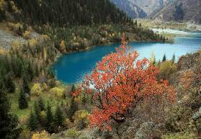
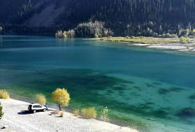

Day 4: Astana
At 08:00 a.m. you will arrive in Astana. Meeting with the guide and transfer to the city (early check-in and breakfast are not included in the cost). You will see the Constitution Square, Presidential Centre of Culture of the Republic of Kazakhstan. At the museum you will see the Golden man, well known not only in the Kazakh steppe but also in all Central Asia. Then you will visit shopping center Khan Shatyr. Then you take the elevator to the top of the “Astana-Baiterek” monument, where you can admire the magnificent panorama of the Kazakhstan capital from the special observation deck. After lunch you will cross Ishym river and get to the Kazakh Eli Square. There you will visit another unique project - the Palace of Peace and Accord, and also see the extraordinary beauty of Khazret Sultan mosque. Final point of the excursion will be the Palace of Independence, where you can look at the far-reaching plans of the development of Astana in the hall "Layout Astana until 2030". Transfer to the hotel.

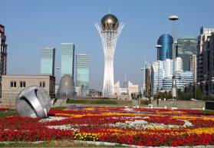
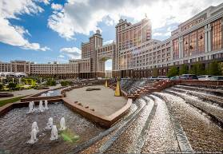

Day 5: Astana – Alzhir – Astana
It is an Akmola camp for the wives of traitors of Motherland - one of the largest camps of Soviet Union and one of the three "islands" of the "Gulag Archipelago". The exposition of the museum is located on hall perimeter that involves the visitor in a vicious circle and immerses in the historical past of Kazakhstan. At the end of excursion you will watch 20-minute documentary film. After lunch you will see the hunting with birds of prey is traditional for all Central Asian nomads. A rider with a golden eagle sitting on the wrist has always been a symbol of the Asian steppes. Falconry is practiced in many countries, but hunting with eagles on hares and foxes is an exceptional attraction of Kazakhstan. In Kazakhstan, hunters with eagles are called «Berkutchi». After demonstration of hunting you will get a complete picture of the traditional hunting with eagles, which has far-historical roots. In the evening is transfer to the hotel.
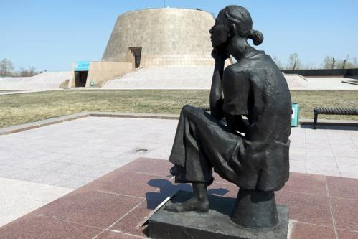
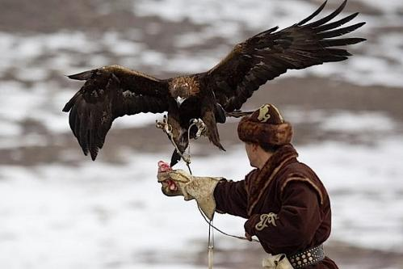

Day 6: Flight
Transfer to the airport.

Persons | Price per person in USD
Persons | Option A | Option B
2 | 985 | 1070
4 | 700 | 790
6 | 560 | 650
8 | 480 | 570
10 | 430 | 520
10+1 Foc | 530 | 620
15+1 Foc | 510 | 610
20+1 Foc | 455 | 540
25+1 Foc | 390 | 485
30+1 Foc | 365 | 455
35+1 Foc | 345 | 435
40+1 Foc | 330 | 420
Single Supplement | 120 | 180
Early check in | 50 | 70
Early check in single | 70 | 100
HB | 125
FB | 200
Extra breakfast on 3rd day | 15

Cities | Nights | Option A | Option B
Almaty | Two | Kazakhstan 3* | Kazzhol 4*
Astana | Two | Tengry 3* | Kazzhol 4*

Price includes:
- Accommodation at mentioned hotels on double share basis
- Transportation per program in comfortable a/c transport with professional drivers
- Breakfasts at the hotels
- Daily two bottles of 0.5l water per person
- Group tour leader in single room on Foc base (+1 Foc)
- Escort English speaking guide
- Entrance fees to mentioned sights per program (excluding photo and video charges at sights)
- Train tickets Almaty –Astana (1 compartment for 4 pax)

Price does not include:
- Visa consular fees and processing expenses
- Visa support to Kazakhstan
- Photo and video charges at sights
- International air tickets to / out of Almaty
- Travel Insurance
- Extras, not indicated in inclusions

PS:
- Pricing valid for contracted partners only for mentioned dates
- If mentioned hotels are overbooked or not available, we will give appropriate alternative.
- If there are more than 20 people, the hunter cannot demonstrate the hawk hunting show.

Payment:
- Tour payment should be made not less than 40 days prior to tourist group arrival to our bank account as per sent invoice.
- The rooming list should be finalized 30 days before arrival.

Cancellation fees:
- No charges up to 45 calendar days up to tour starting date
- 50% of full package price up to 14 calendar days up to tour starting date
- 100% of full package price – 7 or less working days up to tour starting date or no show.

